Final Project Write Up

This projected analyzed population statistics of various racial groups to understand movement and growth. The results are displayed in an interactive visualization. The data represented population estimates of racial group sizes ranging from years 1990 to 2011. The project is divided into three segments: finding the data, importing and analyzing the data, and creating visualization for the results.

The data came from the Unites States of America’s government website, census.gov. This website includes vast amounts of data that all centralizes around data collected from various census efforts. The data for this project is population estimates by state and racial group from 1990 to 2011. The states include all of the U.S. states and the District of Columbia. The racial groups include White Non-Hispanic, Black or African American, Native American or Alaskan Native, Asian or Pacific Islander, Mixed Race, Hispanic, Hispanic White, and Hispanic Non-White. Hispanic Non-White is a result of data cleaning and is an aggregate of various Hispanic sub racial groups not identifying as Hispanic White. The data itself comes in two file formats, text files and excel spreadsheets.

Importing and analyzing the data was completed through a java application. This application read in the data files, cleaned, and then stored the information local to the application for analysis. The analysis for this project is done for three different year range groupings including 5 year, 10 year, and all years grouping. Each grouping data set includes total difference in population change, percent change in population, and growth rate. Each data set is included for all the states and the District of Columbia. For instance, the analysis can be visualized in the following structure seen in Figure 1.

|  |  |  |  |
| --- | --- | --- | --- |
|  | Total | White | … |
| Total | |  |  |  | | --- | --- | --- | | Total change | Percent Change | Growth Rate | | 9999 | 9.99 | .9% | | |  |  |  | | --- | --- | --- | | Total change | Percent Change | Growth Rate | | 999 | 9.99 | .9% | | … |
| Alabama | |  |  |  | | --- | --- | --- | | Total change | Percent Change | Growth Rate | | 9999 | 9.99 | .9% | | |  |  |  | | --- | --- | --- | | Total change | Percent Change | Growth Rate | | 9999 | 9.99 | .9% | | … |
| … | … | … | … |

Figure 1. Visual Representation of analyzed data result structure

The output of the java application is two JavaScript files that contain JavaScript Object Notation (JSON) objects. AllStateData.js represents the entire census data collected from the data import. ComputedStateData.js represents the results of the analysis.

The visualization for the project includes a web page that renders two different types of interactive charts showing the data. The first chart displays the entire census data in different formats including line, bar, and area charts. The chart can be filtered by race or state allowing for dynamic view of trends from every option of the data. This can be seen in Figure 2, where the chart is filtered to show the total population and white population for Alabama and Colorado.

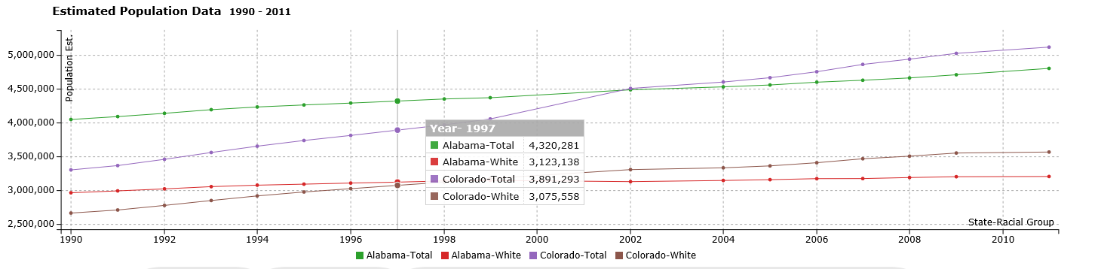

Figure 2. Alabama and Colorado Total and White Population Line Chart

The second chart shows the analyzed data in the form of a Google Geo-Chart. The chart can be filtered by the data sets (total population change, percent change, and growth rate) and race to view the data from different perspectives. An example of the Geo-Chart can be seen in Figure 3.

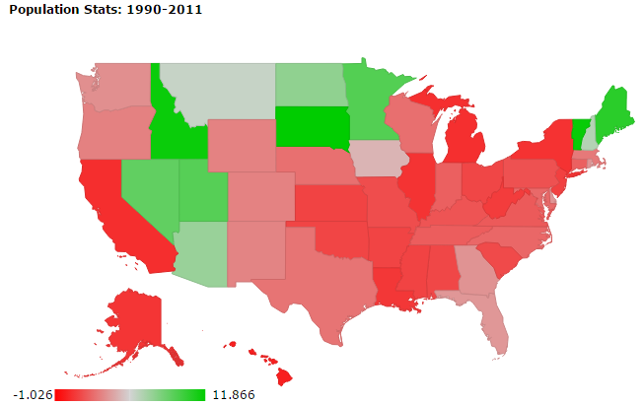

Figure 3. All Years Grouping Geo Chart of Growth for Black/African American racial group

The results of the analysis are better understood when viewing it in the visualization. In general, a few noteworthy observations follow. The white population growth rates from 1990 to 2011 of states in the west, excluding California, are notably higher than any other region of the United States. However, California showed a growth rate decline over the same period, possibly indicating movement away from California to surrounding states. The overall Hispanic population grew strongly throughout the United States, but grew particularly higher in the south compare to other regions. North Carolina had a 46.3 percent growth rate, which lead the nation.

This java application was originally built and complied against Java SE 8. It is recommended that the software be ran in a Java SE 8 environment. The visualization requires an active internet connection and a modern web browser, more specially one that supports HTML5 and CSS3. It is recommended that Chrome or Firefox be used to view the visualization.

There are two ways to run the java program and view the visualization. The first way is to download the compress file named FinalProjectZip.zip. Decompress the file and run the executable jar file, CensusData_FinalProject.jar. The result of CensusData_FinalProject.jar is two JavaScript files located in the Output folder. Navigate to the Output folder and launch Visualization.html in a web browser. The second way to run the program is download the entire GitHub repository and open it as a project in NetBeans IDE. From NetBeans, run or build the project to create the needed JavaScript files in the Output folder. The navigate to Output folder (BDAA34717_Final-Project/Output/) and launch Visualization.html. All the project files are available via GitHub under the account JustinAErvin and the repository name BDAA34717_Final-Project.

As mentioned earlier, the visualization contains two chart types. The first is an interactive chart were the chart type can be changed between line, bar, and graph. The viewer can filter the chart by race and state, selecting more than one state or race at once. The second chart is a Google Geo-Chart. The viewer can filter this chart by the different data set types including total difference, percent increase, and growth rate. The viewer can also filter the chart by racial group.

GitHub Repository URL: <https://github.com/JustinAErvin/BDAA34717_Final-Project>

Sources

<http://www.census.gov/popest/data/historical/index.html>

<http://c3js.org/>

<https://poi.apache.org/>

<http://jquery.com/>